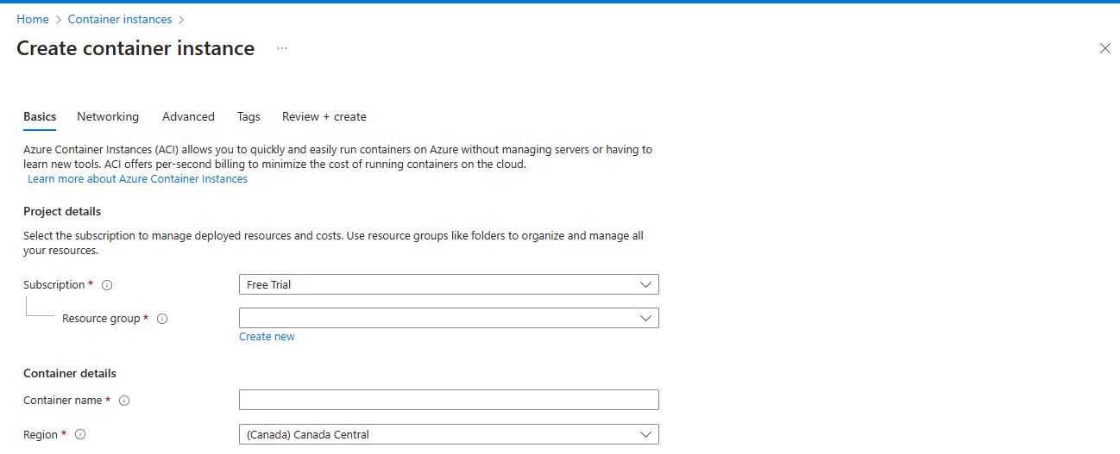

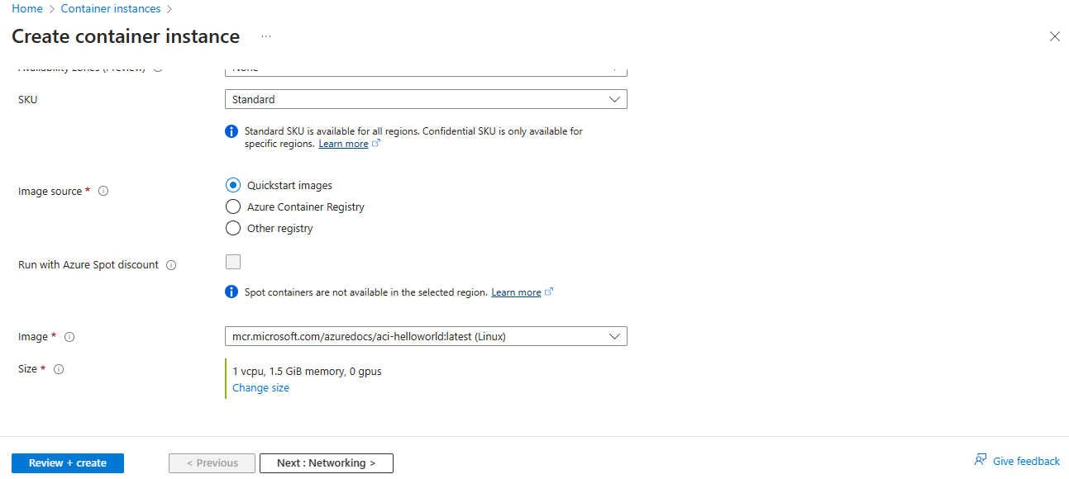

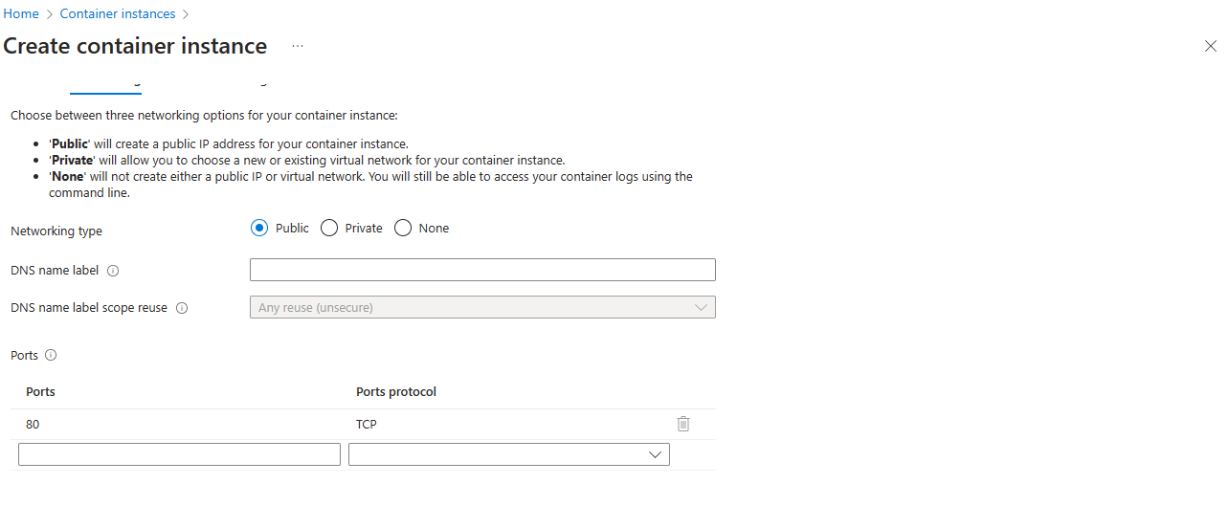

Docker build and docker push to docker hub

docker build -t purushothamantr/api:dev .

docker login

docker push purushothamantr/api:dev

